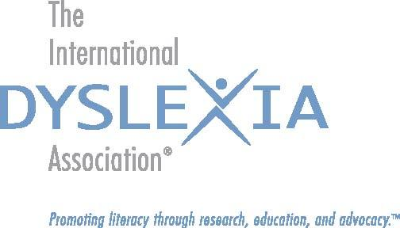

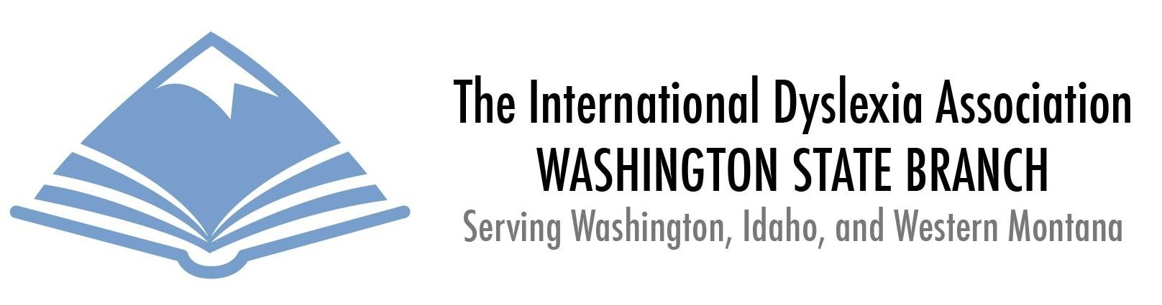

Request To Be Listed in Referral for Services Database

As a local branch of the International Dyslexia Association (IDA), WABIDA is committed to helping ensure families are able to connect with referrals and resources that have been identified in knowledge and training as falling within the evidence-based best practices of multi-sensory literacy instruction.
1. Personal Information:

Name: _____________________ Title: ________ *IDA Member #:__________
* IDA Membership is a requirement to be listed on the Referral List.

Street Address: ________________________________________

City: ______________________ State: ____ Zip: __________

Business Phone: ________________ Cell/Home: __________________________

Email Address: _________________________ Website: ___________________

2. Professional Title / Role: (check all that apply)

⬜ Educational Diagnostician ⬜ Reading Specialist
⬜ Educational / Academic Therapist ⬜ Dyslexia / LD Support
⬜ Tutor of Academic Subjects ⬜ Advocate, IEP & 504 Plans
⬜ Lawyer ⬜ Psychologist
⬜ Speech-Language Pathologist ⬜ Psychiatrist
⬜ Social Worker ⬜ Other ___________________

3. Ages Served:

⬜ Elementary ⬜ Middle School ⬜ High School ⬜ College Students / Adults

4. Areas of Competence:

⬜ Educational /  Academic Therapy | ⬜ ADD/ADHD Coaching | ⬜ Post-Secondary  Planning / Transition
⬜ Reading | ⬜ Advocacy | ⬜ Assistive Technology
⬜ Writing | ⬜ Math | ⬜ College Preparation
⬜ Organizational &  Study Skills | Other Content Areas:  ⬜ Science  ⬜ English  ⬜ __________ | ⬜ SAT / ACT / Grad. / Prof. Exam preparation
Other: ____________ | Other: ____________ | Other: ____________

Please state the training and certification you have that make you competent in these areas:
________________________________________________________________________________________________________________________________________________________________________________________________________________________________________________________________________________________________________________________________________________________________________________________________________________

5. Teaching Methods, Programs, & Techniques:

Research has shown that individuals who have dyslexia or specific learning disabilities (SLD) benefit most from instruction that is multi-sensory, explicit, direct, cumulative and focused on the structure of language. It is IDA’s goal that professional practitioners have specific preparation in the prevention and remediation of language-based reading and writing difficulties.

View a list of teacher training programs accredited by IDA here.
Read more about Multisensory Structured Language Teaching here.

Please list any programs or teaching methodologies you utilize in your work:

⬜ Orton-Gillingham | ⬜ The Spalding Method® | ⬜ The Herman Method TM
⬜ Language!TM | ⬜ Wilson Reading System® | ⬜ Lindamood-Bell® Method
⬜ Alphabet Phonics | ⬜ The Slingerland® Approach | ⬜ Sonday® System
⬜ Wired for Reading TM | ⬜ Linguistic Remedies SM | ⬜ Other ____________
⬜ Other ____________ | ⬜ Other ____________ | ⬜ Other ____________

Practicum Location and Experience:

For each of the approaches you indicated above, please list your practicum and experience in implementation:

Location: Role / Title: Dates of
Practicum:
_____________________ ___________________ ___________

_____________________ ___________________ ___________

_____________________ ___________________ ___________

_____________________ ___________________ ___________

6. Educational Background:

Institution: Degree: Year Awarded:

______________________ ___________________ ___________

______________________ ___________________ ___________

7. Professional Experience:

Place of Employment: Professional Role / Title: Dates of
Employment:

_____________________ ___________________ ___________

_____________________ ___________________ ___________

PLEASE READ THE FOLLOWING STATEMENT CAREFULLY BEFORE SIGNING:

By my signature below, I certify and attest that all the statements and representations I have made in this form are true. Additionally, I certify and attest that I have not been convicted of any felony or crimes involving professional malfeasance, abuse of any kind, or crimes against persons. I have passed the Washington State background check and can provide evidence of this, should I be asked. I also acknowledge that a disclaimer will accompany any information disseminated by WABIDA which indicates that all service providers listed in the database have signed this verification statement. I understand that listing in the WABIDA database requires membership in IDA and is at the COMPLETE AND SOLE DISCRETION of WABIDA. By submitting this application, I agree to accept WABIDA’s determination regarding this request to be listed.

Signature: ________________________________ Date: ________________

